Home BP monitoring

Name : ……………………………………………................................................ DoB: …………………………………………

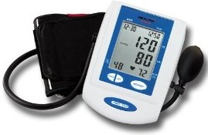

- Ensure sitting in correct position and use validated automatic BP monitor
- Take 2 consecutive measurements at least one minute apart.
- Record your blood pressure at least twice daily, ideally in the morning and evening.
- Continue this for 7 days and enter the values in the table below.
- Please ensure if you are taking blood pressure medication, that you take you blood pressure at least 2 hours after you have taken your medication.

 | Morning 1 | Morning 2 | Evening 1 | Evening 2
Day 1

Day 2

Day 3

Day 4

Day 5

Day 6

Day 7

Average BP:

Discard the measurements taken on the first day and use the average value of all the remaining measurements (in the grey boxes):

- Add top numbers (systolic) in grey boxes & divide ny number of readings
- Add the bottom numbers (diastolic) in grey boxes & divide by number of readings

